7.1 Editors - 3D View - Tool Shelf
Tool Shelf in Object Mode - Create Tab 2
Mesh Panel 3
Mesh 3
Plane 3
Last Operator Add Plane Panel 3
Cube 3
Last Operator Add Cube Panel 3
Circle 4
Last Operator Add Circle Panel 4
UV Sphere 4
Last Operator Add UV Sphere Panel 4
Ico Sphere 4
Last Operator Add Ico Sphere Panel 4
Cylinder 4
Last Operator Add Circle Panel 5
Cone 5
Last Operator Add Cone Panel 5
Torus 5
Last Operator Add Torus Panel 5
Grid 6
Last Operator Add Grid Panel 6
Monkey 6
Last Operator Add Monkey Panel 6
Misc Panel 6
Text 7
Last Operator Add Text 7
Armature 7
Last Operator Add Armature 7
Lattice 7
Usage 7
Last Operator Add Lattice object 7
Camera 8
Last Operator Add Camera 8
Speaker 8
Last Operator Add Speaker 8
Group Instance 8
Addons Add 8
Curve Panel 9
Bezier 9
Circle 9
Nurbs Curve 9
Nurbs Circle 9
Path 9
Last Operator Add Curve 9
Draw Curve 9
Surface Panel 10
Nurbs Curve 10
Nurbs Circle 10
Nurbs Surface 10
Nurbs Cylinder 10
Nurbs Sphere 10
Nurbs Torus 10
Last Operator Add Surface 10
Metaballs Panel 10
Ball 11
Capsule 11
Plane 11
Ellipsoid 11
Cube 11
Last Operator Add Meta ball 11
Group Instance 11
Lamp Panel 11
Point 11
Sun 12
Spot 12
Hemi 12
Area 12
Last Operator Add Lamp 12
Empties Panel 12
Last Operator Add Empty 12
Force Field Panel 13
Last Operator Add Effector 13
Add Modals Panel 13
Mini Lightlib Panel 15
Select Asset 15
Append Asset 15
Path Edit box 15
Simple Usage 16
Preparation 16
Load Assets 16
The available light set-ups 16

Tool Shelf in Object Mode - Create Tab

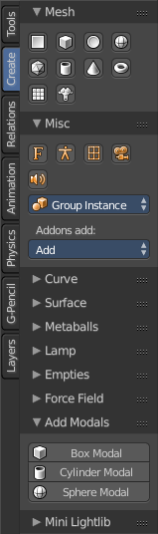
The Create tab provides you with some pre made objects. Mesh Objects, Lamps, Empties, etc. .
When you create a primitive then the Last Operator Panel shows some settings for this primitive.
Note that those settings are not longer available when you perform any operation at the object. And be it to move the primitive. Some of those settings might still be available in the Properties editor. But things like create UV not. So when you want to adjust those settings, then do it immediately after creation.
Several object types can be edited. A Mesh Primitive for example. They have different modes available then. Some not. Like an Empty. There is just the Object mode available for an Empty.

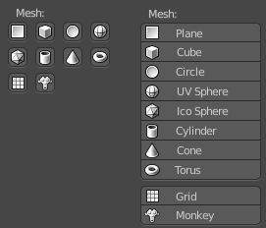
Mesh Panel

Mesh
The Mesh section contains the primitives that are made of meshes.
Mesh primitives are a good starting point for polygon modelling.

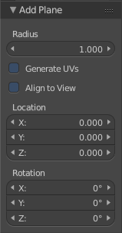
Plane
Plane creates a simple quad mesh

Last Operator Add Plane Panel
Radius is in real the size of the plane.
Generate UV's creates UV's for this primitive.
Align to view aligns the Plane to the current view.
Location Here you can adjust the location of the Plane.
Rotation defines the rotation of the Plane.

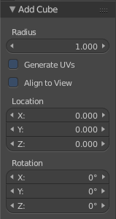
Cube
Cube creates a Cube mesh.

Last Operator Add Cube Panel
Radius is in real the size of the Cube.
Generate UV's creates UV's for this primitive.
Align to view aligns the Cube to the current view.
Location defines the location of the Cube.
Rotation defines the rotation of the Cube.

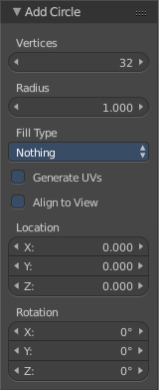
Circle
Circle creates a Circle mesh.

Last Operator Add Circle Panel
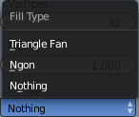
Vertices defines of how much vertices the circle is made.
Radius defines the radius of the circle.
Fill Type defines how the Circle mesh is filled.
- Nothing means you have pure edge geometry.
- N-Gon means that the circle face is a N-Gon face.
- Triangle Fan means that the circle face is triangulated.
Generate UV's creates UV's for this primitive.
Align to view aligns the Circle to the current view.
Location defines the location of the Circle.
Rotation defines the rotation of the Circle.

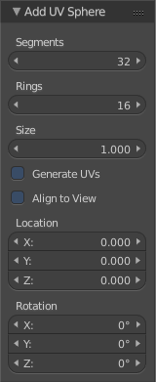
UV Sphere
UV Sphere creates a sphere mesh.

Last Operator Add UV Sphere Panel
Segments defines of how much segments the sphere has vertically.
Rings defines how much rings the sphere has horizontally.
Size defines the radius of the UV Sphere.
Generate UV's creates UV's for this primitive.
Align to view aligns the Sphere to the current view.
Location defines the location of the Sphere.
Rotation defines the rotation of the Sphere.

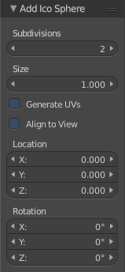
Ico Sphere
Ico Sphere creates a sphere mesh.

Last Operator Add Ico Sphere Panel
Subdivisions defines the subdivision level of the Ico Sphere.
Size defines the radius of the Ico Sphere.
Generate UV's creates UV's for this primitive.
Align to view aligns the Sphere to the current view.
Location defines the location of the Sphere.
Rotation defines the rotation of the Sphere.

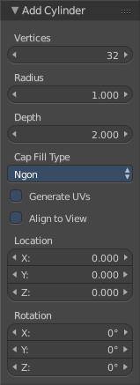
Cylinder
Cylinder creates a Cylinder mesh.

Last Operator Add Circle Panel
Vertices defines of how much vertices the circle is made.
Radius defines the radius of the Cylinder.
Depth defines the length of the Cylinder.
Cap Fill Type defines how the cap face is filled.
- Nothing means you have no face at the top and the bottom of the Cylinder.
- N-Gon means that the cap face is a N-Gon face.
- Triangle Fan means that the cap face is triangulated.
Generate UV's creates UV's for this primitive.
Align to view aligns the Cylinder to the current view.
Location defines the location of the Cylinder.
Rotation defines the rotation of the Cylinder.

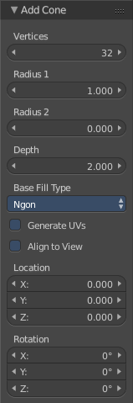
Cone
Cone creates a Cone mesh

Last Operator Add Cone Panel
Vertices defines of how much vertices the circle is made.
Radius 1 defines the base radius of the Cone.
Radius 2 defines the top radius of the Cone.
Depth defines the length of the Cone.
Base Fill Type defines how the Base face is filled.
- Nothing means you have no base face.
- N-Gon means that the base face is a N-Gon face.
- Triangle Fan means that the base face is triangulated.
Generate UV's creates UV's for this primitive.
Align to view aligns the Cone to the current view.
Location defines the location of the Cone.
Rotation defines the rotation of the Cone.

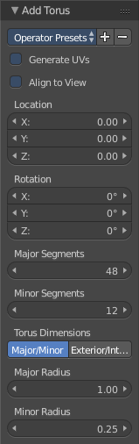
Torus
Torus creates a Torus mesh

Last Operator Add Torus Panel
Operator Presets allows you to store presets for the Torus. So that you don't have to start from scratch when you need different tori with different setup. This presets are temporary. And cannot be stored between sessions.
Align to view aligns the Cone to the current view.
Location defines the location of the Torus.
Rotation defines the rotation of the Torus.
Major segments defines the segment division of the Torus.
Minor segments defines the circle division of the Torus.
Torus Dimensions defines the method to use when changing Major and Minor Radius.
Major Radius changes the radius of the Torus.
Minor Radius changes the thickness of the Torus.

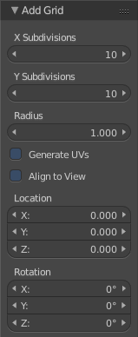
Grid
Grid creates a subidividable plane mesh

Last Operator Add Grid Panel
X Subdivisions defines the number of subdivisions in x direction.
X Subdivisions defines the number of subdivisions in Y direction.
Radius is in real the size of the plane.
Generate UV's creates UV's for this primitive.
Align to view aligns the Plane to the current view.
Location Here you can adjust the location of the Plane.
Rotation defines the rotation of the Plane.

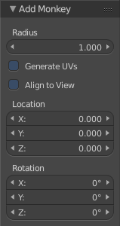
Monkey
Monkey creates a monkey head mesh.

Last Operator Add Monkey Panel
Radius is in real the size of the Monkey head mesh.
Align to view aligns the Monkey head mesh to the current view.
Location Here you can adjust the location of the Monkey head mesh.
Rotation defines the rotation of the Monkey head mesh.

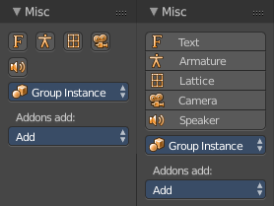
Misc Panel
The Misc Panel provides you with the buttons to create several types of objects. Here you will find mainly the objects that are not for modelling. But everything else. Lights, Bones, Camera, Empties etc.
And it containst the Group Instance menu and the legacy Add menu, which gets used for older addons. Quite a few, like the Sapling addon, places their entries here.

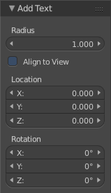
Text
Text creates a text object. Text is not mesh geometry. It is a special curve geometry.
Note
You can enter the Edit mode with the standard hotkey. But you cannot switch back to Object mode with the standard hotkey. Since this hotkey gets count as input for the text object in Edit mode. You have to use the mode drop-down box to leave the Edit mode.

Last Operator Add Text
Radius is in real the size of the Text object.
Align to view aligns the Text object to the current view.
Location Here you can adjust the location of the Text object.
Rotation defines the rotation of the Text object.

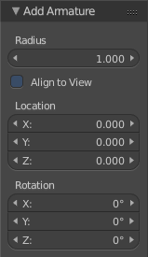
Armature
Armature creates a Armature. It adds the first bone of a skeleton.

Last Operator Add Armature
Radius is in real the size of the Armature object.
Align to view aligns the Armature object to the current view.
Location Here you can adjust the location of the Armature object.
Rotation defines the rotation of the Armature object.

Lattice
Lattice creates a Lattice. Which is a control cage to control deforming at another object.

Usage
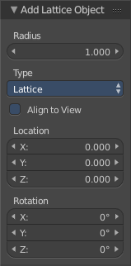
Create a Lattice object.
Make sure it is bigger than the object that you want to deform, and is around this object.
Add a Lattice Modifier to the object that you want to deform.
In the Object box of the Lattice Modifier add our created Lattice object.
Select Lattice Object. Enter Edit mode. And here you can deform the Lattice Object now, and the object to deform will follow.

Last Operator Add Lattice object
Radius is in real the size of the Lattice object.
Type is a drop-down box where you can define the type of Lattice object.
Align to view aligns the Lattice object to the current view.
Location Here you can adjust the location of the Lattice object.
Rotation defines the rotation of the Lattice object.

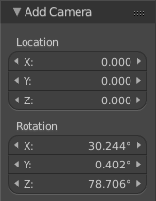
Camera
Camera creates a Camera object.

Last Operator Add Camera
Location Here you can adjust the location of the Camera object.
Rotation defines the rotation of the Camera object.

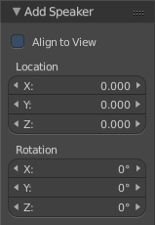
Speaker
Speaker creates a Speaker object.

Last Operator Add Speaker
Location Here you can adjust the location of the Speaker object.
Rotation defines the rotation of the Speaker object.

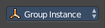
Group Instance
Group Instance is a drop-down box that contains the current groups. And you can add another instance of an existing group by clicking at the group in this drop-down list.
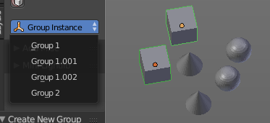
First create a group. It will display in the list.
Then click at one of the list items to add an instance of the group to the scene.

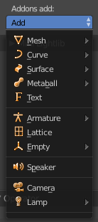
Addons Add
The Addons Add menu exists for historical reasons. Quite a few Blender addons adds their entries into this add menu. And so we have to keep it in Bforartists too. But it is now in the Tool Shelf, and not in the Header menu anymore like in Blender.
There are a handful of double menu entries left that cannot be removed for exact this reason. We would make some addons disfunctional.

Curve Panel
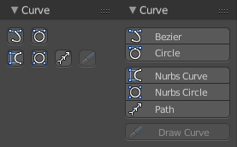
The Curve section contains the Curve primitives. Curves are handy to create curved shapes. Or a camera path.
The curve types are very similar. But do have some small differences. The difference between Bezier and Nurbs is that with Bezier you have handlers at the curve. And with a Nurbs you have a control geometry to influence the curve.
Note that Curves is no mesh data. You have to convert the Curves data to Mesh data when you want to work with it like with a mesh. Note also that you cannot convert it back to curve then.

Bezier
Bezier creates a Bezier type curve.

Circle
Circle creates a Bezier circle type curve.

Nurbs Curve
Nurbs Curve creates a Nurbs type curve.

Nurbs Circle
Nurbs Circle creates a Nurbs type circle curve.

Path
Path creates a Nurbs type curve.

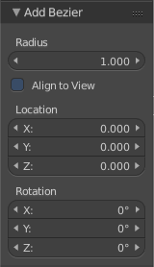
Last Operator Add Curve
The Last Operator add panel is for all curves equal.
Radius is in real the size of the curve.
Align to view aligns the curve to the current view.
Location Here you can adjust the location of the curve.
Rotation defines the rotation of the curve.

Draw Curve
Draw Curve is just active in Edit mode.

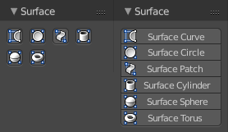
Surface Panel
The Surface section contains the Surface primitives. Surfaces are some kind of curves. But curves with which you can construct surfaces. Surfaces are all of type Nurbs curves.
Surfaces are handy to construct curved surfaces.
Note that Surfaces similar to Curves is no mesh data. You have to convert the Surfaces data to Mesh data when you want to work with it like with a mesh. Note also that you cannot convert it back to Surface then.

Nurbs Curve
Nurbs Curve creates a Nurbs type curve.

Nurbs Circle
Nurbs Circle creates a Nurbs type circle.

Nurbs Surface
Nurbs Surface creates a Nurbs type Surface.

Nurbs Cylinder
Nurbs Cylinder creates a Nurbs type cylinder.

Nurbs Sphere
Nurbs Sphere creates a Nurbs type sphere.

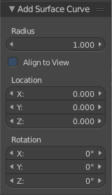
Nurbs Torus
Nurbs Torus creates a Nurbs type Torus.

Last Operator Add Surface
The Last Operator add panel is for all curves equal.
Radius is in real the size of the surface.
Align to view aligns the surface to the current view.
Location Here you can adjust the location of the surface.
Rotation defines the rotation of the surface.

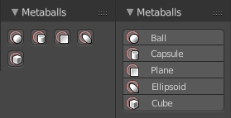
Metaballs Panel
Meta-balls are procedural primitives. They are not defined by vertices or curves. The interesting behaviour of meta-balls is that you can stick them into each other. And they have one surface then. Like merging two water drops. And this works in Object mode already.

Ball
Ball creates a meta-ball in Sphere shape.

Capsule
Capsule creates a meta-ball in Capsule shape.

Plane
Plane creates a meta-ball in Plane shape.

Ellipsoid
Ellipsoid creates a meta-ball in Ellipsoid shape.

Cube
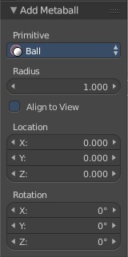
Cube creates a meta-ball in Cube shape.

Last Operator Add Meta ball
The Last Operator add panel is for all Meta-balls equal.
Primitive is a drop-down box where you can change the Meta ball type.
Radius is in real the size of the surface.
Align to view aligns the surface to the current view.
Location Here you can adjust the location of the surface.
Rotation defines the rotation of the surface.

Group Instance
Group Instance is a drop-down box that contains the current groups. And you can add another instance of an existing group by clicking at the group in this drop-down list.
First create a group. It will display in the list.
Then click at one of the list items to add an instance of the group to the scene.

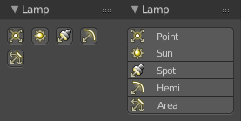
Lamp Panel
The lamps brings light into your scene. There are five different Lamp types.

Point
Point creates a Point Light. A point light shines into all directions.

Sun
Sun creates a light that behaves like a sun. It's a directional light.

Spot
Spot creates a Spot light. It's a directional light.

Hemi
Hemi creates a hemi light. It illuminates the whole scene.

Area
Area creates a Area light. It's a directional light.

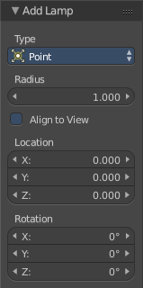
Last Operator Add Lamp
The Last Operator add panel is for all Lamps equal
Type is a drop-down box where you can change the light type.
Radius is in real the size of the surface.
Align to view aligns the surface to the current view.
Location Here you can adjust the location of the surface.
Rotation defines the rotation of the surface.

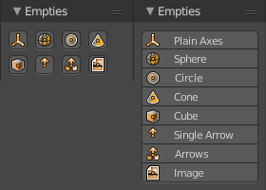
Empties Panel
An Empty is an object without any data attached. It is basically just a container. Empties can be used as anchor objects. Or as visible handlers at a skeleton for example.
The empty types differs just by how they gets displayed in the viewport.

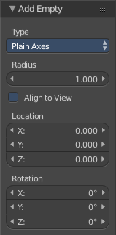
Last Operator Add Empty
Type is a drop-down box where you can define the type of Empty object.
Radius is in real the size of the Empty object.
Align to view aligns the Empty object to the current view.
Location Here you can adjust the location of the Empty object.
Rotation defines the rotation of the Empty object.

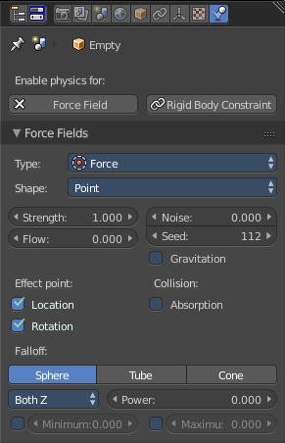
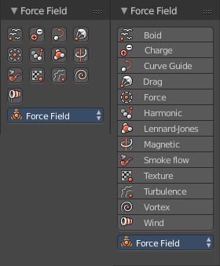
Force Field Panel
A Force Field is for physical simulations. It provides you with tools to add different forces to objects. Wind, Smoke, Gravity, Magnetic, etc. .
The added Force Fields can be further adjusted in the Properties panel then.
There is also the legacy dropdown menu available. it's a double menu, it contains the same buttons again. But some addons adds their entries here.

A Force Field is internally also called Effector. So our Last Operator panel has the title Add Effector.

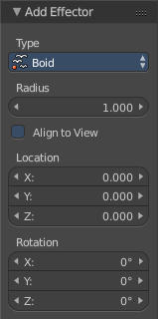
Last Operator Add Effector
Type is a drop-down box where you can define the type of Effector.
Radius is in real the size of the Effector.
Align to view aligns the Text object to the Effector.
Location Here you can adjust the location of the Effector.
Rotation defines the rotation of the Effector.

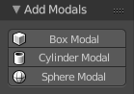
Add Modals Panel
Add Modals allows you to create primitives with adjustable divisions in 3DS Max style.
First you drag a rectangle in the 3D view. Then you drag the height. Then you adjust the divisions in the Last Operator.
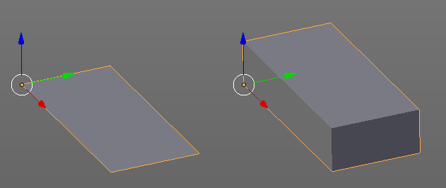

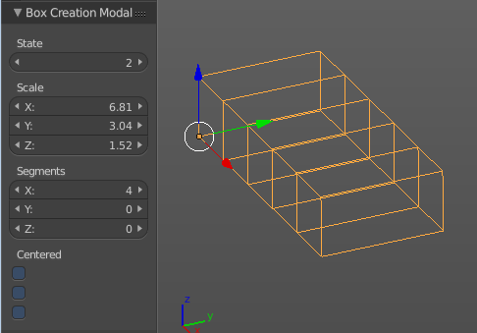

Add Modals is an addon. You can turn it off in the User Preferences when you don't need it.
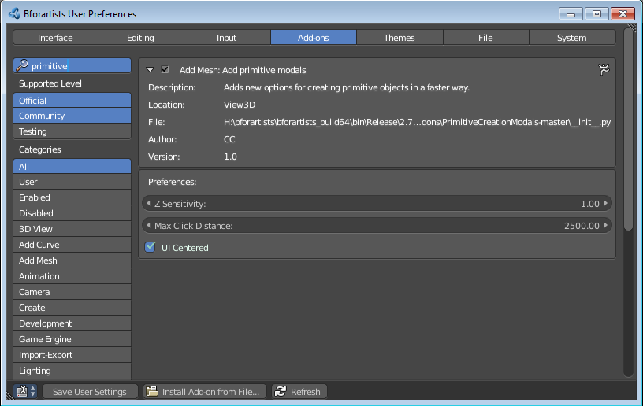

Mini Lightlib Panel
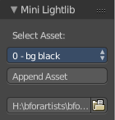
Mini Lightlib is a little add-on that gives you some standard lighting settings for the Cycles renderer. It contains for example the classical three-point setup. But also some basic volumetrics examples.

It can be turned off in the User Preferences.

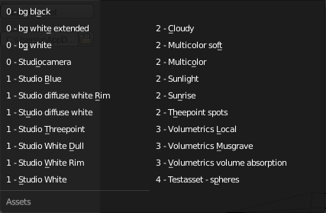
Select Asset
The Select Asset drop-down box contains the assets that comes with Mini Lightlib. Here you can select what you want to load.
The assets are grouped by numbers.
0 is everything setup. We have three backgrounds here. And the studio camera that fits to the setup.
1 are the light set-ups for a studio setup. From classical three-point to white.
2 is everything not studio setup.
3 are some volumetrics set-ups. Be very careful with this ones. Especially the Musgrave example renders eons.
4 is the included test asset. Some colored spheres.

Append Asset
The Append Asset Button appends what is currently selected in the drop-down box to the scene.

Path Edit box
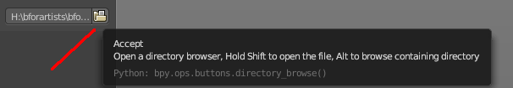
The Path Edit box shows the path to the library. You will usually not touch this edit box. This edit box gives you a hint where the Mini Lightlib library is located. So that you can add your own assets to that folder. At Windows it's in the Appdata Directory. Which is usually hidden and protected. You might need to adjust your rights to access this folder directly.
But it is also a Path selector. You can select other library folders here if you want, and append the assets from that folder. The Drop-down box will show the content of all blend files in this folder then.
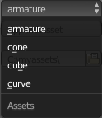
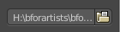
Every blend file is also a library file. The add-on appends the content of this blend file then. To make your own library file is as easy as saving your blend file with your asset. That's already a library. But note that Mini Lightlib will append the whole content from this blend file. There is no filter as in the Blender append feature. So when you plan to create your own libraries, then take care to remove everything except the asset that you want to load.
Note that changes in the Path Edit box are not permanent. The path to the Mini Lightlib is hard-coded. So when you restart Blender then every change is gone. That's also a quick method to get the original path to the light library back. Restart Blender.

Simple Usage

Preparation

Make sure that you have the Cycles renderer selected!

Mini Lightlib is made for the Cycles renderer. It will not work with the Blender Internal renderer. At least not without adjustments.

Throw out all lights and cameras from the scene.
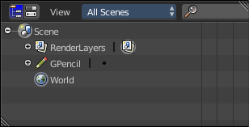
We don't want to have the standard lights ruin the result. Also the standard camera does not fit to our studio setup.

This can be done in the Outliner. Or you select the lights and camera in the viewport and hit delete.

Load Assets

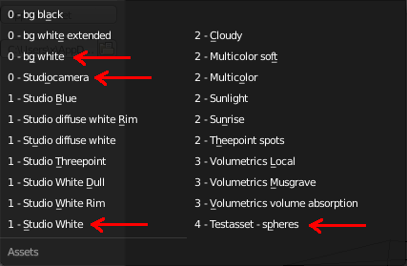
Select in the drop-down box what you want to append. And append it one by one to the scene.

Let's start with a studio setup. I suggest to use the bg white, which is a white background. The camera. One of the studio light set-ups. And finally our test asset to have something to render.

So we select bg white, and click at the Append Asset Button.
Then we select Studiocamera, and click at the Append Asset Button.
Then we select let's say the Studio White, and click at the Append Asset Button.
And then we select the Test asset Spheres, and click at the Append Asset Button. What's left is to click at the render button.

The available light set-ups
Here you can get an overview how the result looks like for the different lighting set-ups.

Be careful with the volumetrics examples. Especially the Musgrave example can render eons.



